Chapter 11
Creating Custom Web Controls
About This Chapter
Custom controls extend the tools available to Web developers. Using custom controls, you can encapsulate key aspects of the visual interface and program logic that you want to reuse throughout your application, or throughout your organization. Microsoft Visual Studio .NET provides three types of custom control for use on Web forms. In this chapter, you’ll learn how to develop and use each of these controls:
- Web user controls
These combine existing server and HTML controls by using the Visual Studio .NET Designer to create functional units that encapsulate some aspect of the user interface. User controls reside in content files, which must be included in the project in which the controls are used.
- Composite custom controls
These create new controls from existing server and HTML controls. Although similar to user controls, composite controls are created in code rather than visually, and therefore they can be compiled into an assembly (.dll), which can be shared between multiple applications and used from the Toolbox in Visual Studio .NET.
- Rendered custom controls
These create entirely new controls by rendering HTML directly rather than using composition. These controls are compiled and can be used from the Toolbox, just like composite controls, but you must write extra code to handle tasks that are performed automatically in composite controls.
Before You Begin
To complete this chapter, you must:
- Be familiar with the life cycle of Web applications.
- Understand object-oriented programming techniques, namespaces, and state information issues, as discussed in Chapter 3, “Working with Web Objects.”
- Have experience developing Web applications with the standard server and HTML controls.
Lesson 1: Creating Web User Controls
Web user controls combine one or more server or HTML controls on a Web user control page, which can, in turn, be used on a Web form as a single control. User controls make it possible to create a single visual component that uses several controls to perform a specific task.
Once created, user controls can be used on Web forms throughout a project. However, because they are not compiled into assemblies, they have the following limitations not found with other types of controls:
- A copy of the control must exist in each Web application project in which the control is used.
- User controls can’t be loaded in the Visual Studio .NET Toolbox; instead, you must create them by dragging the control from Solution Explorer to the Web form.
- User control code is initialized after the Web form loads, which means that user control property values are not updated until after the Web form’s Load event.
In this lesson, you’ll learn how to create user controls and how to use them on a Web form.
After this lesson, you will be able to
- Create a Web application that contains and uses user controls
- Add properties, methods, and events to a user control
- Include the user control on a Web form by editing the Web form’s HTML
- Enable design-time settings, such as grid layout, for a user control
Estimated lesson time: 30 minutes
Creating and Using User Controls
There are five steps to creating and using a user control in a Web application:
- Add a Web user control page (.ascx) to your project.
- Draw the visual interface of the control in the designer.
- Write code to create the control’s properties, methods, and events.
- Use the control on a Web form by dragging it from Solution Explorer to the Web form on which you want to include it.
- Use the control from a Web form’s code by declaring the control at the module level and then using the control’s methods, properties, and events as needed within the Web form.
The following sections describe these steps in greater detail. The last section, “Enabling Grid Layout,” describes special considerations you need to take into account when working with user controls.
Creating a User Control and Drawing Its Interface
You create user controls out of other server and HTML controls in the Visual Studio .NET Toolbox. You do this by drawing the controls on a user control page, which is simply another file type in a Web application project, just like a Web form or an HTML page. User controls are identified by their .ascx file extensions.
To create a user control and add it to a Web application, follow these steps:
- From the Project menu, choose Add Web User Control. Visual Studio .NET displays the Add New Item dialog box.
- Type the name of the user control in the Name box, and click OK. Visual Studio .NET creates a new, blank user control page and adds it to the project, as shown in Figure 11-1.
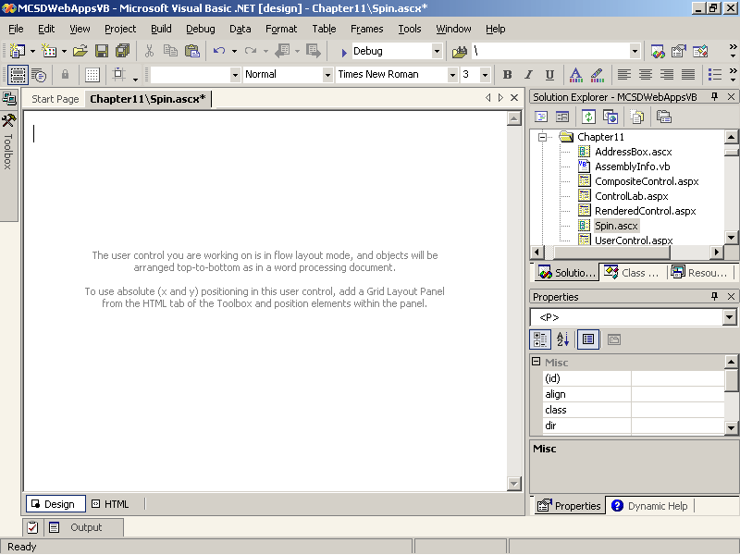
Figure 11-1. A new, blank user control page
After you’ve added a user control page to your project, create the visual interface of the control by adding server or HTML controls to it. User controls support flow layout only, so if you want to position controls on the page using grid layout, add an HTML Grid Layout Panel control to the user control as a container for the controls you want to position. Figure 11-2 shows a simple user control created by placing two Button server controls on an HTML Grid Layout Panel control.
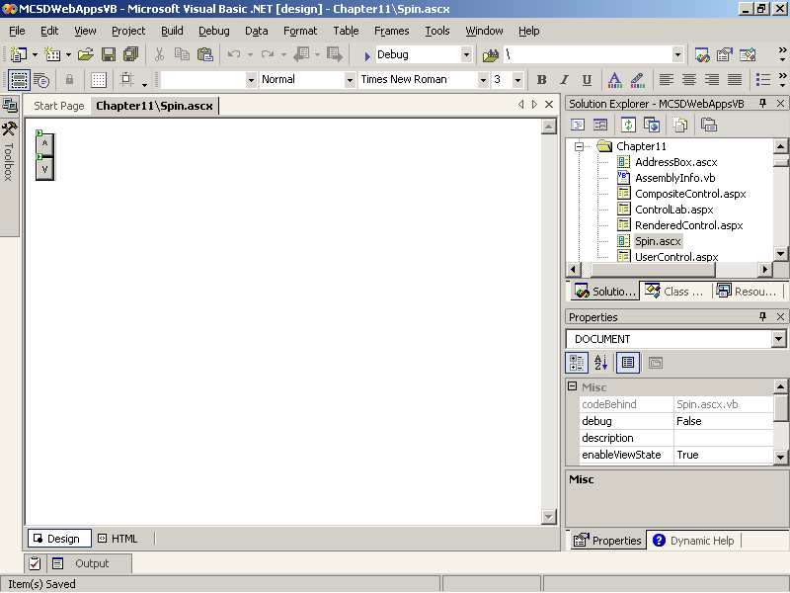
Figure 11-2. A simple user control
The control shown in Figure 11-2 is the Web form’s equivalent of a Spin control. The control allows you to increment or decrement a value by clicking the up or down arrow. This example is used in the sections that follow; the HTML for the user control is shown here for reference:
<DIV id="pnlGrid" runat="server" style="WIDTH: 20px; POSITION: relative;
HEIGHT: 48px" ms_positioning="GridLayout">
<asp:Button id="butUp" Text="^" runat="server" />
<asp:Button id="butDown" Text="v" runat="server" />
</DIV>
Writing the Control’s Properties, Methods, and Events
You manipulate the controls you add to the user control from the user control’s code module. That allows you to hide the inner workings of the control and expose the tasks the control performs as properties, methods, and events.
To edit the user control’s code module, simply double-click the user control. Visual Studio .NET automatically generates the code template shown in Figure 11-3 when you create a user control.
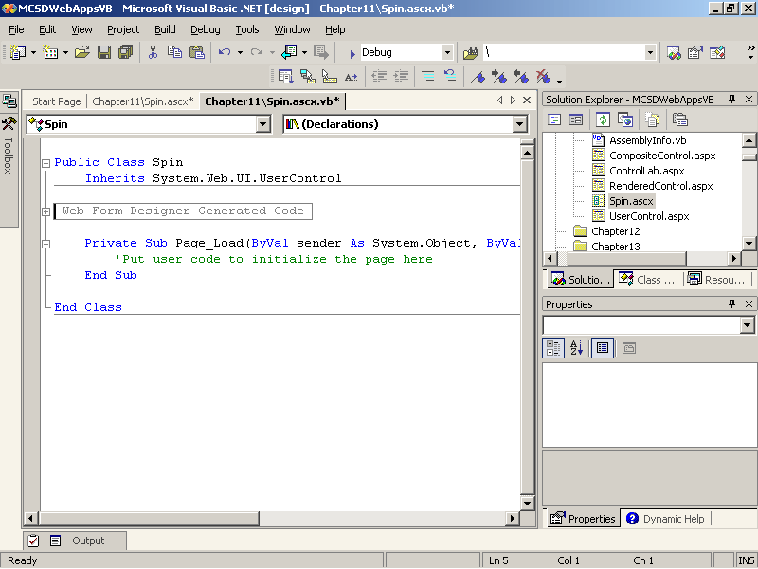
Figure 11-3. The user control code template (Visual Basic .NET)
The code in Figure 11-3 is similar to the generated code for a Web form, with these notable differences:
- The user control’s class is based on the System.Web.UI.UserControl base class.
This base class provides the base set of properties and methods you use to create the control and get the control’s design-time settings from its HTML attributes on the Web form.
- The user control’s Load event occurs when the control is loaded by the Web form that contains it.
The control’s Load event procedure runs after the Web form’s Load event procedure, which is important to remember when you work with user controls on a Web form.
To create properties and methods for the user control that you can use from a Web form, follow these steps:
- Create the public property or method that you want to make available on the containing Web form.
- Write code to respond to events that occur for the controls contained within the user control. These event procedures do the bulk of the work for the user control.
- If the property or method needs to retain a setting between page displays, write code to save and restore settings from the control’s ViewState.
For example, the following code shows a Value property that returns the value of the Spin control created in the preceding section:
Visual Basic .NET
Public Property Value() As Integer
Get
' Return the Value.
Return ViewState("Value")
End Get
Set(ByVal Value As Integer)
' Set the Value.
ViewState("Value") = Value
End Set
End Property
Visual C#
public int Value
{
get
{
// Return the Value.
return Convert.ToInt32(ViewState["Value"]);
}
set
{
// Set the Value.
ViewState["Value"] = value;
}
}
The user changes the value of the Spin control by clicking the up and down buttons, so the following code increments or decrements the value, depending on which button the user clicks:
Visual Basic .NET
Private Sub butDown_Click(ByVal sender As System.Object, _
ByVal e As System.EventArgs) Handles butDown.Click
' Decrement the Value.
Me.Value -= 1
End Sub

Private Sub butUp_Click(ByVal sender As System.Object, _
ByVal e As System.EventArgs) Handles butUp.Click
' Increment the Value.
Me.Value += 1
End Sub
Visual C#
private void butDown_Click(object sender, System.EventArgs e)
{
// Decrement the Value.
this.Value -= 1;
}

private void butUp_Click(object sender, System.EventArgs e)
{
// Increment the Value.
this.Value += 1;
}
Adding the Control to a Web Form
User controls can be dragged directly from Solution Explorer onto a Web form. When you add a user control to a Web form in this way, Visual Studio .NET generates a @Register directive and HTML tags to create the control on the Web form.
For example, the following sample shows the HTML generated when you drag the Spin user control onto a Web form:
<%@ Register TagPrefix="uc1" TagName="Spin" Src="Spin.ascx" %>
<%@ Page Language="vb" AutoEventWireup="false" Codebehind="UserControl.aspx.vb" Inherits="MCSDWebAppsVB.UserControl" %>
<HTML>
<body>
<form id="Form1" method="post" runat="server">
<uc1:Spin id="Spin1" runat="server" Value="5"></uc1:Spin>
</form>
</body>
</HTML>
User controls can exist alongside and interact with other controls on a Web form. For example, the following HTML shows the Spin user control next to a TextBox control:
<%@ Register TagPrefix="uc1" TagName="Spin" Src="Spin.ascx" %>
<%@ Page Language="vb" AutoEventWireup="false" Codebehind="UserControl.aspx.vb" Inherits="MCSDWebAppsVB.UserControl" %>
<HTML>
<body>
<form id="Form1" method="post" runat="server">
<h2>Creating and Using User Controls</h2>
<hr>
<asp:TextBox id="TextBox1" runat="server"></asp:TextBox>
<uc1:Spin id="Spin1" runat="server" Value="5"></uc1:Spin>
</form>
</body>
</HTML>
Notice that the user control includes an attribute for the Value property. When the Spin control loads at run time, Microsoft ASP.NET will set the control’s properties based on the attributes in the HTML. The control’s attributes provide a way to set the control’s properties from HTML.
When you view the preceding HTML in Visual Studio .NET’s Design mode, it appears as shown in Figure 11-4.
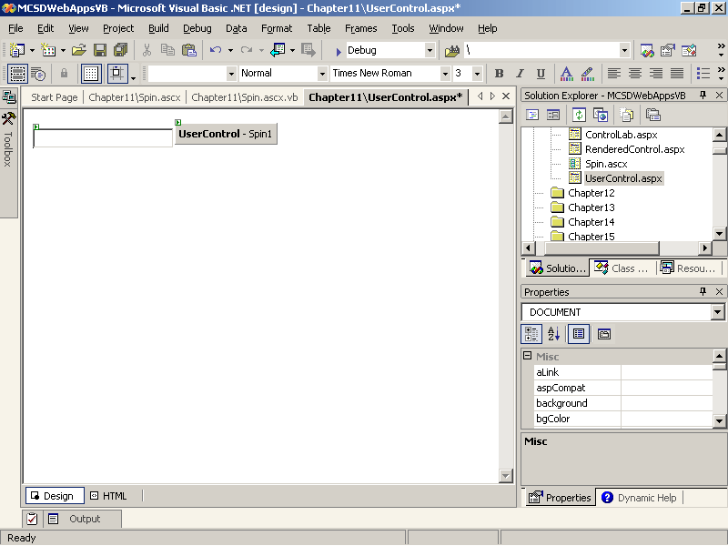
Figure 11-4. The Spin user control on a Web form
As you’ll notice in Figure 11-4, the Web Forms Designer doesn’t display the user control as it will appear at run time. Instead, it shows a sort of generic control. This is a limitation of Visual Studio .NET—it can’t display user controls in Design mode.
Another thing you’ll notice is that the Spin control supports only flow layout on the Web form. That is a limitation of the control itself. To support grid layout and absolute positioning on the Web form, you have to add code to support the style attribute. You’ll see that technique later in this lesson.
Using the Control in Code
After you’ve created a user control and added it to a Web form, you can use it from the Web form’s code module by following these steps:
- Declare the user control at the module level. For example, the following line declares the Spin user control that was added to the Web form in the preceding section:
Visual Basic .NET
Protected WithEvents Spin1 As Spin
Visual C#
protected Spin Spin1;
- Use the control’s properties, methods, and events as you would any other control. For example, the following event procedure displays the Spin control’s value in a text box:
Visual Basic .NET
Private Sub Page_PreRender(ByVal sender As System.Object, _
ByVal e As System.EventArgs) Handles MyBase.PreRender
' Display the Spin control's value.
TextBox1.Text = Spin1.Value
End Sub
Visual C#
private void Page_PreRender(object sender, System.EventArgs e)
{
// Display the Spin control's value.
TextBox1.Text = Spin1.Value.ToString();
}
One very important thing to notice here is that the preceding code uses the Web form’s PreRender event, not its Load event. If you use the Load event, you’ll see only the Value set in the user control’s HTML Value attribute the first time you click the Spin control. (Try it!) That’s because the user control’s code doesn’t run until after the Web form’s Load event has finished. Any changes that were saved in the control’s ViewState aren’t loaded until the control’s Load event procedure has run.
Adding Events to the User Control
In addition to properties and methods, user controls can provide events that can respond to user actions on the Web form.
To add an event to a user control, follow these steps:
- Declare the event within the user control’s code module. For example, the following code declares a Click event for the Spin user control:
Visual Basic .NET
' Declare event for Spin control.
Public Event Click(ByVal sender As System.Object, ByVal e As
System.EventArgs)
Visual C#
// Declare the event.
public event EventHandler Click;
- Create a method to raise the event. This step makes it easier for other classes to derive from this class, because they can override this method.
Visual Basic .NET
' Method to raise event.
Protected Overridable Sub OnClick(ByVal e As EventArgs)
RaiseEvent Click(Me, e)
End Sub
Visual C#
// Method to raise event.
protected virtual void OnClick(EventArgs e)
{
if (Click != null)
{
Click(this, e);
}
}
- Raise the event from within the user control’s code. For example, the following code raises the Click event whenever a user clicks the up or down buttons in the Spin user control:
Visual Basic .NET
Private Sub butDown_Click(ByVal sender As System.Object, _
ByVal e As System.EventArgs) Handles butDown.Click
' Decrement the Value.
Me.Value -= 1
' Call the OnClick method.
OnClick(e)
End Sub

Private Sub butUp_Click(ByVal sender As System.Object, _
ByVal e As System.EventArgs) Handles butUp.Click
' Increment the Value.
Me.Value += 1
' Call the OnClick method.
OnClick(e)
End Sub
Visual C#
private void butDown_Click(object sender, System.EventArgs e)
{
// Decrement the Value.
this.Value -= 1;
// Call the OnClick method.
OnClick(e);
}

private void butUp_Click(object sender, System.EventArgs e)
{
// Increment the Value.
this.Value += 1;
// Call the OnClick method.
}
To use the user control event from a Web form, include the user control on a Web form, as shown in the preceding two sections, and then write an event procedure that responds to the event. For example, the following code updates a text box when the user clicks the Spin control:
Visual Basic .NET
Private Sub Spin1_Click(ByVal sender As Object, _
ByVal e As System.EventArgs) Handles Spin1.Click
' Update info from the user control's event handler.
TextBox1.Text = Spin1.Value
End Sub
Visual C#
private void InitializeComponent()
{
// Add this line to wire the event.
this.Spin1.Click += new System.EventHandler(this.Spin1_Click);
}

private void Spin1_Click(object sender, System.EventArgs e)
{
// Display the Spin control's value.
TextBox1.Text = Spin1.Value.ToString();
}
Enabling Grid Layout
As mentioned, user controls don’t have built-in support for the absolute positioning used by a Web form’s grid layout. In ASP.NET, controls support absolute positioning through the style attribute. You can simply add a style attribute to your user control’s HTML on the Web form to get design-time support for absolute positioning. For example, the following HTML creates a Spin user control that you can drag to different locations on a Web form in Design mode:
<UserControl:Spin id="Spin1" runat="server" Value="5"
style="Z-INDEX: 101; LEFT: 248px; POSITION: absolute; TOP: 88px">
</UserControl:Spin>
You’ll see the problem with this solution as soon as you run the Web application, however. At run time, ASP.NET ignores the style attribute and displays the Spin user control using flow layout.
To make the style attribute work, you have to add a Style property to the user control to set the control’s position and size based on the attribute settings. If your control uses a container, such as the Grid Layout Panel used by the Spin user control, you can simply pass the user control’s style attribute to the Panel control, as shown in the following code:
Visual Basic .NET
Public Property Style() As String
Get
' Return the containing Panel control's style attribute.
Return pnlGrid.Attributes("style")
End Get
Set(ByVal Value As String)
' Set the containing Panel control's style attribute.
pnlGrid.Attributes("style") = Value
End Set
End Property
Visual C#
public string Style
{
get
{
// Return the containing Panel control's style attribute.
return pnlGrid.Attributes["style"];
}
set
{
// Set the containing Panel control's style attribute.
pnlGrid.Attributes["style"] = value;
}
}
You can use this same programming technique—sometimes called delegation—to implement other standard control attributes such as Visible, Enabled, or BackColor. Simply add a property to the user control that passes the attribute value to a containing control using the Attributes property, as shown in the preceding code.
Lesson 2: Creating Composite Custom Controls
Composite custom controls combine one or more server or HTML controls within a single control class, which can be compiled along with other control classes to create an assembly (.dll) that contains a custom control library. Once created, the custom control library can be loaded into Visual Studio .NET and used in the same way as the standard server and HTML controls.
Composite custom controls are functionally similar to user controls, but they reside in their own assemblies, so you can share the same control among multiple projects without having to copy the control to each project, as you must do with user controls. However, composite controls are somewhat more difficult to create because you can’t draw them visually using the Visual Studio .NET Designer. You have many more options for defining their behavior, however, so composite controls are more complex than user controls.
After this lesson, you will be able to
- Create a two-project solution that you can use to develop and debug composite custom controls
- Add a composite custom control to a Web form in a test project by manually using the @Register directive and HTML tags
- Create a composite custom control’s appearance by adding controls to it using the CreateChildControls method
- Create properties, methods, and events for a composite custom control
- Handle design-time changes to the control, such as resizing or repositioning on a Web form using grid layout
- Create new controls by deriving directly from a single server control
Estimated lesson time: 35 minutes
Creating and Using Composite Custom Controls
There are six steps to creating and using a custom control in a Web application:
- Create a solution containing a custom control project.
- Add a Web application project to the solution, and set it as the startup project. You will use the Web application project to test the custom control during development.
- Add a project reference from the Web application to the custom control project, and add an HTML @Register directive and control element to use the custom control on a Web form.
- Create the custom control’s visual interface by adding existing controls to it through the custom control’s CreateChildControls method.
- Add the properties, methods, and events that the custom control provides.
- Build and test the custom control.
The following sections describe these steps in greater detail.
Creating the Custom Control Project
Custom controls are simply classes that are built into an assembly. These custom control classes inherit much of their behavior from the WebControl class, and they implement various interfaces, depending on the type of control you’re creating.
The easiest way to get started is to use the Web Control Library project template provided by Visual Studio .NET. To create a custom control using the project template, follow these steps:
- From the File menu, point to New, and then select Project. Visual Studio .NET displays the New Project dialog box, as shown in Figure 11-5.
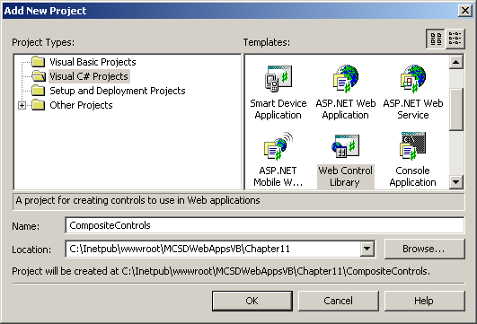
Figure 11-5. Creating a new custom control project
- Select the Web Control Library template icon from the Templates list, type the name of the project in the Name box, and click OK. Visual Studio .NET creates a project containing code for a single custom control named WebControl1, as shown in Figure 11-6.
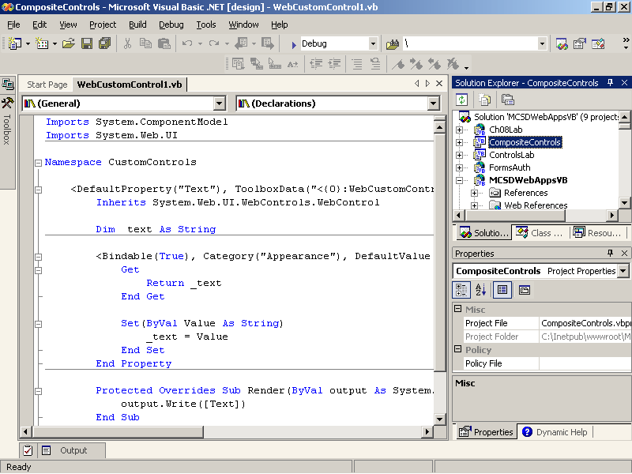
Figure 11-6. The custom control code template (Visual Basic .NET)
The code shown in Figure 11-6 serves as a template for creating a new custom control. The template includes a class named WebControl1 that contains one property, which is named Text as shown in the following code.
Visual Basic .NET
Imports System.ComponentModel
Imports System.Web.UI

<DefaultProperty("Text"), ToolboxData("<{0}:WebCustomControl1 _
runat=server></{0}:WebCustomControl1>")>
Public Class WebCustomControl1
Inherits System.Web.UI.WebControls.WebControl

Dim _text As String

<Bindable(True), Category("Appearance"), DefaultValue("")> _
Property [Text]() As String
Get
Return _text
End Get

Set(ByVal Value As String)
_text = Value
End Set
End Property

Protected Overrides Sub Render(ByVal output As _
System.Web.UI.HtmlTextWriter)
output.Write([Text])
End Sub

End Class
Visual C#
using System;
using System.Web.UI;
using System.Web.UI.WebControls;
using System.ComponentModel;

namespace CompositeControls
{
/// <summary>
/// Summary description for WebCustomControl1.
/// </summary>
[DefaultProperty("Text"),
ToolboxData("<{0}:WebCustomControl1
runat=server></{0}:WebCustomControl1>")]
public class WebCustomControl1 : System.Web.UI.WebControls.WebControl
{
private string text;

[Bindable(true),
Category("Appearance"),
DefaultValue("")]
public string Text
{
get
{
return text;
}

set
{
text = value;
}
}

/// <summary>
/// Render this control to the output parameter specified.
/// </summary>
/// <param name="output"> The HTML writer to write out to </param>
protected override void Render(HtmlTextWriter output)
{
output.Write(Text);
}
}
}
The preceding code contains some elements you might not have seen before. Table 11-1 describes each of these items in turn.
Table 11-1. The Custom Control Template
Part | Name | Description
<DefaultProperty("Text"),  ToolboxData("<{0}:  WebCustomControl1  runat=server></{0}:  WebCustomControl1>")>  [DefaultProperty("Text"),  ToolboxData("<{0}:  WebCustomControl1  runat=server></{0}:  WebCustomControl1>")] | Class attributes | Class attributes determine the design-time settings for the control. These values help determine what appears in the Visual Studio .NET Properties window when the custom control is selected on a Web form.
Inherits System.Web.UI.  WebControls.WebControl  : System.Web.UI.WebControls.WebContro l | Base class | Custom controls are derived from one of the base control classes.
<Bindable(True),  Category("Appearance"),  DefaultValue("")>  [Bindable(true),  Category("Appearance"),  DefaultValue("")] | Property attributes | Like class attributes, property attributes specify the design-time settings of a property.
Property [Text]() As String  public string Text | Property definition | The property definition specifies what the property does at run time. The square brackets ([]) indicate that the property name can be a keyword (although in this case, it is not).
Protected Overrides Sub  Render(ByVal output As  System.Web.UI.HtmlTextWriter)  protected  override void  Render(HtmlTextWriter  output) | Render method | The Render method displays the custom control. This overrides the base class’s Render method.
The following sections describe how to add to and modify these parts to create a composite custom control, but for more complete information about attributes, see the Visual Studio .NET Help topic “Design-Time Attributes for Components.”
Creating the Test Project
The custom control project created in the preceding section has the output type of Class Library. This means that the project can be used only from another application—it can’t run as a stand-alone application. To run and debug a custom control in Visual Studio .NET, you must add a second project to the current solution.
To create a custom control test project and add it to the current solution, follow these steps:
- With the custom control project open, point to Add Project on the File menu, and then choose New Project. Visual Studio .NET displays the New Project dialog box.
- Select ASP.NET Web Application from the Templates list, type the name of the project in the Location box, and click OK. Visual Studio .NET creates a new Web application project and adds it to the current solution.
- In Solution Explorer, right-click the Web application project, and select Set As StartUp Project from the shortcut menu. Visual Studio .NET indicates that the Web application is the startup project by displaying the project name in boldface.
- In Solution Explorer, right-click the Web application’s References item, and select Add Reference from the shortcut menu. Visual Studio .NET displays the Add Reference dialog box, as shown in Figure 11-7.
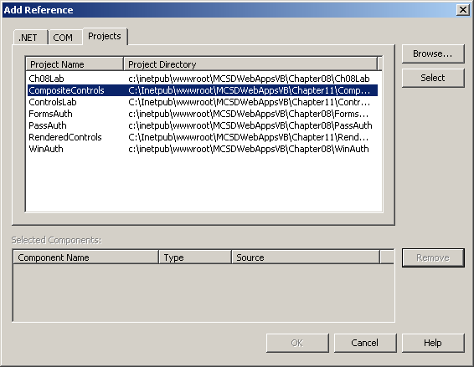
Figure 11-7. Adding a project reference
- Click the Projects tab, click Select to add a reference from the custom control project to the Web application project, and then click OK. Visual Studio .NET adds the reference, as shown in Solution Explorer in Figure 11-8.
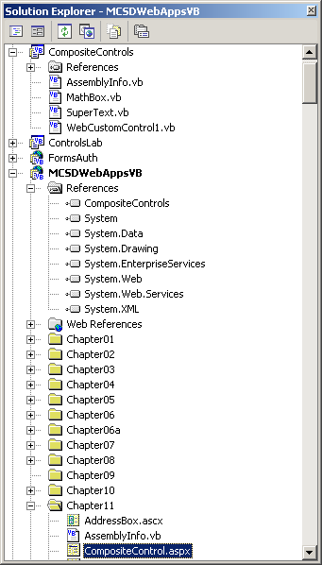
Figure 11-8. The solution
Establishing a project reference as described in the preceding steps copies the custom control assembly (.dll) to the /bin directory of the Web application. This makes the custom control available to the Web application. Any changes to the custom control assembly are automatically copied to the Web application’s /bin directory.
As you develop your custom control, remember that changes aren’t updated in the test Web application until you rebuild the custom control. That happens automatically when you run the application, but not when you switch between the custom control and the test Web application in Design mode. To see changes to the control in Design mode, you must rebuild the custom control before switching to the test application.
Adding the Custom Control to the Test Project
To test and debug the custom control during development, you must add an instance of the control to a Web form in the test Web application created in the preceding section.
To add a custom control to a Web form, follow these steps:
- In the test Web application, display a Web form, and switch to HTML mode by clicking the HTML tab at the bottom left corner of the Design window.
- Add a Register directive to the top of the Web form. For example, the following directive registers the custom control assembly named CompositeControls:
- <%@ Register TagPrefix="Custom" Namespace="CompositeControls"
Assembly="CompositeControls" %>
- Create an instance of the custom control on the Web form using HTML syntax. For example, the following HTML creates an instance of WebCustomControl1 created in the preceding section:
<Custom:WebCustomControl1 id="custTest" runat="server" />
For custom controls, the Register directive’s three attributes have the meanings described in Table 11-2.
Table 11-2. The Register Directive's Attributes
Attribute | Description
TagPrefix | This name identifies the group that the user control belongs to. For example, the tag prefix for ASP.NET server controls is “asp”. You use this prefix to create a naming convention to organize your custom controls.
Namespace | This is the project name and namespace within the custom control assembly that contains the controls to register. Microsoft Visual Basic .NET uses the project name as an implicit namespace, so for controls written in Visual Basic .NET, use the project name.
Assembly | This is the name of the assembly (.dll) containing the custom controls. The control assembly must be referenced by the Web application. As mentioned, referencing the assembly maintains a copy of it in the Web application’s /bin directory.
The @Register directive’s TagPrefix makes up the first part of the name you use in the custom control’s HTML element. The second part is the project name and class name of the control within the assembly. TagPrefix=“Custom” and the class name WebCustomControl1 mean that you create the custom control using an HTML <Custom:WebCustomControl1 …/> element.
Custom controls can exist alongside and interact with other controls on a Web form. For example, the following HTML shows the WebControl1 custom control next to a Button control:
<%@ Page Language="vb" AutoEventWireup="false" Codebehind="Default.aspx.vb"
Inherits="MCSDWebAppsVB.CustomControl"%>
<%@ Register TagPrefix="Custom" NameSpace="CompositeControls "
Assembly="CompositeControls" %>
<HTML>
<body>
<form id="Form1" method="post" runat="server">
<asp:button id="butCount" runat="server" />
<Custom:WebCustomControl1 id="custTest" runat="server"
Text="This is a custom control" />
</form>
</body>
</HTML>
Notice that the custom control includes an attribute for the Text property. The control’s HTML attributes provide a way to set the control’s properties from HTML. Unlike user controls, custom controls are displayed correctly in the Visual Studio .NET Designer, as shown in Figure 11-9.
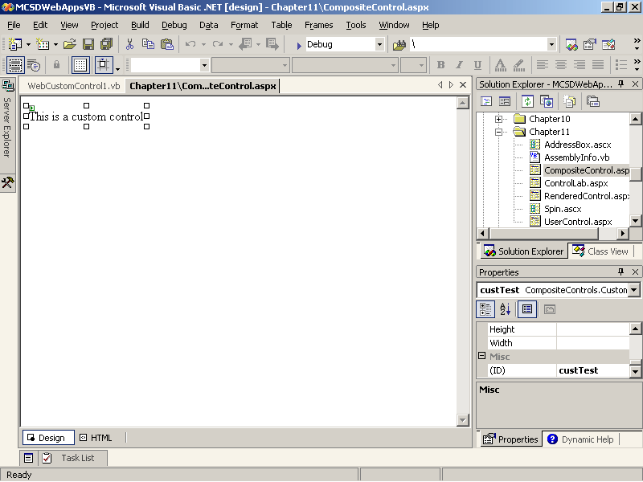
Figure 11-9. The WebControl1 custom control on a Web form (at design time)
Another thing you should notice about custom controls is that when they are selected in the Visual Studio .NET Designer, their properties appear in the Properties window. Again, unlike user controls, custom controls are fully supported by Visual Studio .NET.
To use the custom control in code, simply refer to it as you would any other control. For example, the following Button Click event procedure increments the value shown in the WebCustomControl1 custom control:
Visual Basic .NET
Private Sub butAdd_Click(ByVal sender As System.Object, _
ByVal e As System.EventArgs) Handles butAdd.Click
' Increment the Text property of the custom control.
custTest.Text = Val(custTest.Text) + 1
End Sub
Visual C#
private void butAdd_Click(object sender, System.EventArgs e)
{
// Convert the string to a number.
int intText = 0;
try
{
intText = int.Parse(custTest.Text);
}
catch
{
intText = 0;
}
// Increment the number.
intText ++;
// Display result in control
custTest.Text = intText.ToString();
}
When you run the preceding code as part of a test Web application, ASP.NET displays the Web form with the custom control and the Button server control, as shown in Figure 11-10.
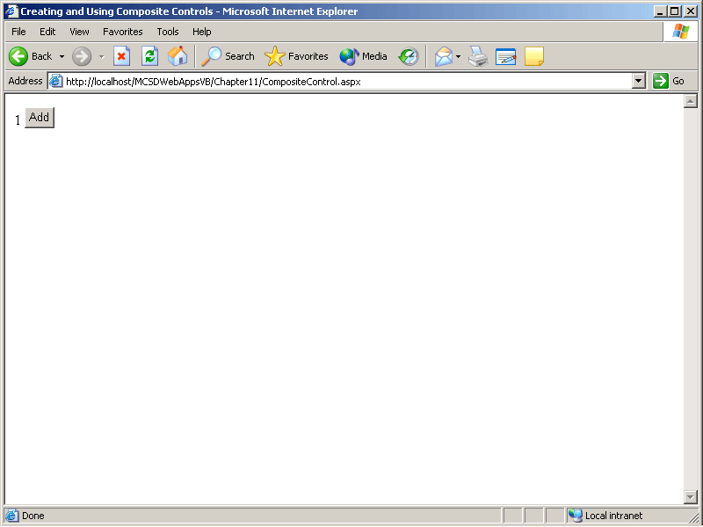
Figure 11-10. The WebControl1 custom control on a Web form (at run time)
If you click the Button control in this example more than once, the displayed value never gets past 1. Whoa! What gives? The custom control template that Visual Studio .NET creates doesn’t take steps to save properties between page displays. To do that, you’ll need to add code, as described in the following sections.
Creating the Composite Control’s Appearance
You create the visual interface of composite custom controls by adding existing server or HTML controls to the Controls collection in the CreateChildControls method. The custom control’s CreateChildControls method overrides the method in the base class.
The following code shows how to create a composite custom control’s appearance. The code creates a composite custom control named MathBox. The MathBox control contains TextBox, Button, and Label controls, which are declared at the class level so that they are available to all procedures in the class. The CreateChildControls procedure adds these controls and some Literal controls to the custom control’s Controls collection to create the custom control’s appearance.
Visual Basic .NET
Public Class MathBox
Inherits System.Web.UI.WebControls.WebControl

Dim txtMath As New TextBox()
Dim butSum As New Button()
Dim lblResult As New Label()

' Create control's appearance.
Protected Overrides Sub CreateChildControls()
' Add the sub controls to this composite control.
' Set the TextMode property and add textbox.
txtMath.TextMode = TextBoxMode.MultiLine
Controls.Add(txtMath)
' Start a new line
Controls.Add(New LiteralControl("<br>"))
' Set the Text property and add the Button control.
butSum.Text = "Sum"
Controls.Add(butSum)
' Add Label and Literals to display result.
Controls.Add(New LiteralControl("&nbsp&nbspResult:&nbsp<b>"))
Controls.Add(lblResult)
Controls.Add(New LiteralControl("</b>"))
End Sub
End Class
Visual C#
public class MathBox : System.Web.UI.WebControls.WebControl
{
TextBox txtMath = new TextBox();
Button butSum = new Button();
Label lblResult = new Label();

private string text;

protected override void CreateChildControls()
{
// Add the sub controls to this composite control.
// Set the TextMode property and add textbox.
txtMath.TextMode = TextBoxMode.MultiLine;
Controls.Add(txtMath);
// Start a new line
Controls.Add(new LiteralControl("<br>"));
// Set the Text property and add the Button control.
butSum.Text = "Sum";
Controls.Add(butSum);
// Add Label and Literals to display result.
Controls.Add(new LiteralControl("&nbsp&nbspResult:&nbsp<b>"));
Controls.Add(lblResult);
Controls.Add(new LiteralControl("</b>"));

}
}
The MathBox class shown in the preceding code is used as the basis for the rest of this lesson. If you add it to the composite control project created in the preceding sections, you can add it to the test Web application using the same @Register directive you added for the WebCustomControl1, and you’ll create an instance of the control with the following HTML:
<Custom:MathBox id="mathTest" runat="server" />
If you add the MathBox custom control to a Web form at this point, you’ll notice it appears as only a small green box at design time. At run time, however, the control will appear as shown in Figure 11-11.
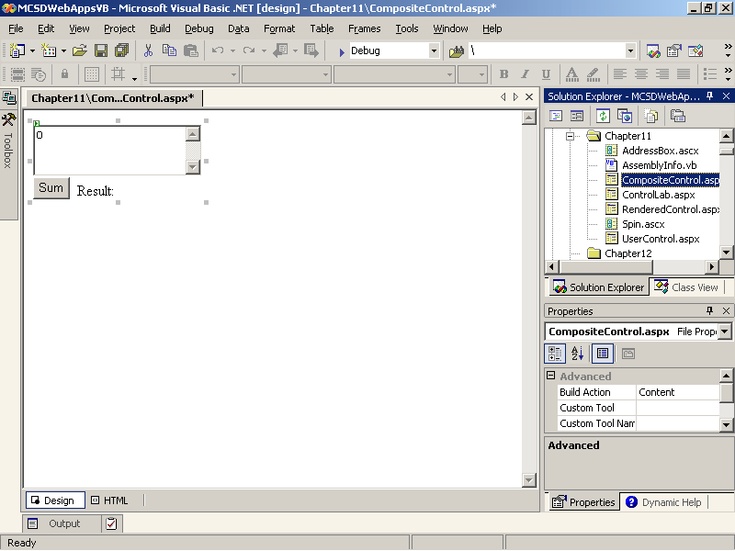
Figure 11-11. The MathBox custom control (at run time)
The MathBox custom control doesn’t have a design-time appearance at this point because it does not yet expose any design-time properties. That problem is remedied in the next section.
You don’t need to override the Render method when creating a composite custom control. The custom control code template that Visual Studio .NET generates overrides this method. Therefore, if you’re using the template, you must delete the generated Render method or change it to delegate back to the base class (making it a null operation), as shown here:
Visual Basic .NET
' Delegate back since not needed in composite control.
Protected Overrides Sub Render(ByVal writer As HtmlTextWriter)
MyBase.Render(writer)
End Sub
Visual C#
// Delegate back since not needed in composite control.
protected override void Render(HtmlTextWriter output)
{
base.Render(output);
}
Creating Properties and Methods
The MathBox custom control will add a list of numbers entered in its text box and return the result. From a design standpoint, that requires two properties: Values, which contains an array of numbers; and Result, which contains the sum of those numbers. It also implies a Sum method to perform the calculation.
The following code shows the Values and Result properties and the Sum method used by MathBox. It also includes a Text property for consistency with the ASP.NET server controls and to simplify setting default text from HTML attributes.
Visual Basic .NET
' MathBox Properties and Methods.
<DefaultValue("")> Property Text() As String
Get
' Make sure child controls exist.
EnsureChildControls()
' Return the text in the TextBox control.
Return txtMath.Text
End Get
Set(ByVal Value As String)
' Make sure child controls exist.
EnsureChildControls()
' Set the text in the TextBox control.
txtMath.Text = Value
End Set
End Property

Property Values() As String()
Get
EnsureChildControls()
' Return an array of strings from the TextBox.
Return txtMath.Text.Split(Chr(13))
End Get
Set(ByVal Value() As String)
EnsureChildControls()
' Set the text in the TextBox from an array.
txtMath.Text = String.Join(Chr(13), Value)
End Set
End Property

ReadOnly Property Result() As String
Get
EnsureChildcontrols()
' Return the result from the Label.
Return lblResult.Text
End Get
End Property

Sub Sum()
EnsureChildcontrols()
' If there is text in the TextBox.
If txtMath.Text.Length Then
' Break the text into an array, line by line.
Dim arrNums As String()
arrNums = txtMath.Text.Split(Chr(13))
Dim strCount As String, dblSum As Double
' Add each element in the array together.
For Each strCount In arrNums
' Use error handling to ignore non-number entries.
Try
dblSum += Convert.ToDouble(strCount)
Catch
End Try
Next
' Display the result in the label.
lblResult.Text = dblSum.ToString
Else
lblResult.Text = "0"
End If
End Sub
Visual C#
// MathBox properties and methods.
[DefaultValue("0")]
public string Text
{
get
{
// Make sure child controls exist.
EnsureChildControls();
// Return the text in the TextBox control.
return txtMath.Text;
}

set
{
// Make sure child controls exist.
EnsureChildControls();
// Set the text in the TextBox control.
txtMath.Text = value;
}
}

char[] strSep = {'\r'};

public string[] Values
{
get
{
EnsureChildControls();
// Return an array of strings from the TextBox.
return txtMath.Text.Split(strSep);
}
set
{
EnsureChildControls();
// Set the text in the TextBox from an array.
txtMath.Text = String.Join(" ", value);
}
}

public string Result
{
get
{
EnsureChildControls();
// Return the result from the Label.
return lblResult.Text;
}
}

public void Sum()
{
EnsureChildControls();
// If there is text in the TextBox.
if (txtMath.Text.Length != 0)
{
// Break the text into an array, line by line.
string[] arrNums;
arrNums = txtMath.Text.Split(strSep);
double dblSum = 0;
// Add each element in the array together.
foreach (string strCount in arrNums)
{
// Use error handling to
// ignore non-number entries.
try
{
dblSum += Convert.ToDouble(strCount);
}
catch
{
}
}
// Display the result in the label.
lblResult.Text = dblSum.ToString();
}
else
lblResult.Text = "0";
}
}
The EnsureChildControls statement in the preceding code ensures that the child controls have been instantiated. You use this in a composite control before referring to any contained controls.
After you add properties and methods to the composite control, rebuild the control to update the control’s assembly. At that point, the composite control should appear in Design mode as well as at run time, as shown in Figure 11-12.
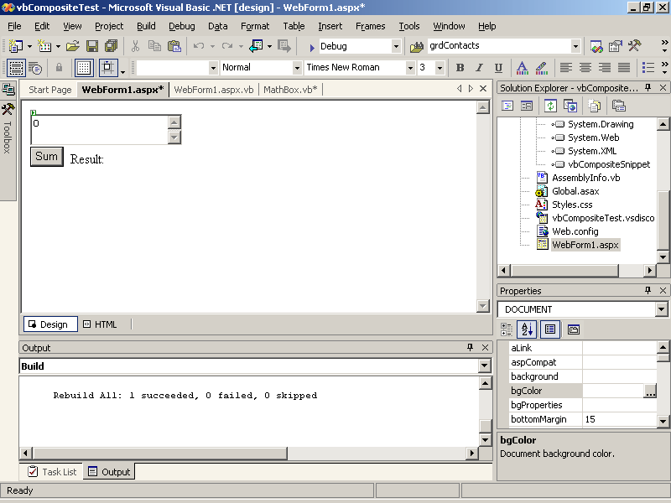
Figure 11-12. The MathBox custom control (at design time)
In Visual Studio .NET, version 1.0, custom controls may not always appear at design time. If this happens, you can usually cause them to appear by setting one of the custom control’s properties, as shown by the following HTML:
<Custom:MathBox id="mthTest" runat="server" Text="0" />
Because composite controls use their base class’s Render method, they automatically support absolute positioning with grid layout. In other words, you can drag composite controls to various positions on a Web form, and they will be displayed there at run time.
Handling Events
So far, the MathBox control can accept values, perform calculations, and display a result, but if you click the Sum button, it doesn’t do any of that.
To enable the Sum button, follow these steps:
- Add an event handler for the button’s Click event to the CreateChildControls procedure using the AddHandler method.
- Create a procedure to handle the event. This procedure has to have the same arguments and return type as the button’s Click event.
The following code shows the additions to the MathBox control in boldface. Notice that the event procedure simply calls the Sum method created earlier to perform the calculation and display the result.
Visual Basic .NET
Protected Overrides Sub CreateChildControls()
' Add the sub controls to this composite control.
' Set the TextMode property and add textbox.
txtMath.TextMode = TextBoxMode.MultiLine
Controls.Add(txtMath)
' Start a new line
Controls.Add(New LiteralControl("<br>"))
' Set the Text property and add the Button control.
butSum.Text = "Sum"
Controls.Add(butSum)
' Add Label and Literals to display result.
Controls.Add(New LiteralControl("&nbsp&nbspResult:&nbsp<b>"))
Controls.Add(lblResult)
Controls.Add(New LiteralControl("</b>"))
' Add a handler for the Button's Click event.
AddHandler butSum.Click, AddressOf Me.butSumClickedEnd Sub

' Event procedure for Button Click
Sub butSumClicked(ByVal source As Object, ByVal e As EventArgs)
' Call the Sum method.
Sum()
End Sub
Visual C#
protected override void CreateChildControls()
{
// Add the sub controls to this composite control.
// Set the TextMode property and add textbox.
txtMath.TextMode = TextBoxMode.MultiLine;
Controls.Add(txtMath);
// Start a new line
Controls.Add(new LiteralControl("<br>"));
// Set the Text property and add the Button control.
butSum.Text = "Sum";
Controls.Add(butSum);
// Add Label and Literals to display result.
Controls.Add(new LiteralControl("&nbsp&nbspResult:&nbsp<b>"));
Controls.Add(lblResult);
Controls.Add(new LiteralControl("</b>"));
// Add event handler.
butSum.Click += new EventHandler(butSumClicked);}

void butSumClicked(object sender, EventArgs e)
{
// Call the Sum method.
Sum();
}
Raising Events
In addition to handling the Sum button’s Click event, you might want to raise an event that can be handled from the Web form containing the custom control.
To raise an event from a custom control, follow these steps:
- Add a public event declaration to the custom control’s class.
- Raise the event from code within the custom control using the control’s event method.
The following code shows how to declare and raise an event from within the MathBox control class:
Visual Basic .NET
' Declare an event
Event Click(ByVal sender As Object, ByVal e As EventArgs)

' Event procedure for Button Click
Sub butSumClicked(ByVal source As Object, ByVal e As EventArgs)
' Call the Sum method.
Sum()
' Call method to raise event.
OnClick(EventArgs.Empty)
End Sub

Protected Overridable Sub OnClick(ByVal e As EventArgs)
' Raise the event.
RaiseEvent Click(Me, e)
End Sub
Visual C#
// Declare the event.
public event EventHandler Click;

void butSumClicked(object sender, EventArgs e)
{
// Call the Sum method.
Sum();
// Call the event method.
OnClick(EventArgs.Empty);
}

protected virtual void OnClick(EventArgs e)
{
if (Click != null)
// Raise the event.
Click(this, e);
}
To make the Click event the default event for the control, add a DefaultEvent attribute to the class declaration. A default event is the event that Visual Studio .NET automatically creates when you double-click the control within the Web form. The following code shows the addition in boldface:
Visual Basic .NET
<DefaultEvent("Click")> Public Class MathBox
Visual C#
[DefaultEvent("Click")]
public class MathBox : System.Web.UI.WebControls.WebControl
To use the MathBox control’s event from a Web form, double-click the control in the test Web form and use the following event procedure:
Visual Basic .NET
Private Sub mathTest_Click(ByVal sender As System.Object, _
ByVal e As System.EventArgs) Handles mathTest.Click
Response.Write(mathTest.Result)
End Sub
Visual C#
private void mthTest_Click(object sender, System.EventArgs e)
{
Response.Write(mthTest.Result.ToString());
}
Handling Control Resizing
Composite controls handle a lot of design-time and run-time display features automatically through their base class’s Render method. However, they can’t automatically resize their child controls because there is no reasonable way to tell what type of resizing behavior is appropriate.
To handle resizing composite controls, follow these steps:
- Override the base class’s Render method.
- Add code to resize the child controls as appropriate.
- Call the base class’s Render method to display the control.
The following code resizes a TextBox child control based on the width and height of the MathBox control:
Visual Basic .NET
Protected Overrides Sub Render(ByVal writer As _
System.Web.UI.HtmlTextWriter)
EnsureChildcontrols()
' Resize text box to match control width.
txtMath.Width = Me.Width
' Resize text box to match control height.
txtMath.Height = Unit.Parse(Me.Height.Value butSum.Height.Value)
' Render the control.
MyBase.Render(writer)
End Sub
Visual C#
protected override void Render(HtmlTextWriter output)
{
EnsureChildControls();
// Resize text box to match control width.
txtMath.Width = this.Width;
// Resize text box to match control height.
double dHeight = this.Height.Value - butSum.Height.Value;
txtMath.Height = Unit.Parse(dHeight.ToString());
// Render the control.
base.Render(output);
}
Superclassing Server Controls
The preceding sections showed you how to create a composite control from multiple existing controls. You can use the same techniques to create new controls from an existing single control to add properties, methods, or events for that control or to change the behavior of that control.
Because that type of custom control is based on only one control, you can derive directly from that control’s class rather than using the more general class of WebControl. Custom controls of this type aren’t really composite controls—they’re sometimes referred to as superclassed controls.
For example, the following SuperText class creates a custom control based on the TextBox server control and adds a method to sort the contents of the text box:
Visual Basic .NET
Public Class SuperText
Inherits System.Web.UI.WebControls.TextBox

' New method for the text box.
Public Sub Sort()
' Create an array.
Dim arrText As String()
' Put the words in the text box into the array.
arrText = Me.Text.Split(" ")
' Sort the array.
Array.Sort(arrText)
' Join the string and put it back in the text box.
Me.Text = String.Join(" ", arrText)
End Sub

End Class
Visual C#
public class SuperText : System.Web.UI.WebControls.TextBox
{

public void Sort()
{
// Create an array.
string[] arrText;
// Put the words in the text box into the array.
char[] strSep = {' '};
arrText = this.Text.Split(strSep);
// Sort the array.
Array.Sort(arrText);
// Join the string and put it back in the text box.
this.Text = String.Join(" ", arrText);
}
}
To use the control from a Web form, register the control’s assembly as shown in the preceding examples, and include the following HTML on a Web form:
<Custom:SuperText id="superTest" runat="server" />
<asp:Button ID="butSort" Runat="server" Text="Sort" />
To test the Sort method, add the following code to the Web form’s code module:
Visual Basic .NET
Private Sub butSort_Click(ByVal sender As System.Object, _
ByVal e As System.EventArgs) Handles butSort.Click
superTest.Sort()
End Sub
Visual C#
private void butSort_Click(object sender, System.EventArgs e)
{
superTest.Sort();
}
At either run time or design time, the SuperText control behaves just like a normal TextBox, as shown in Figure 11-13.
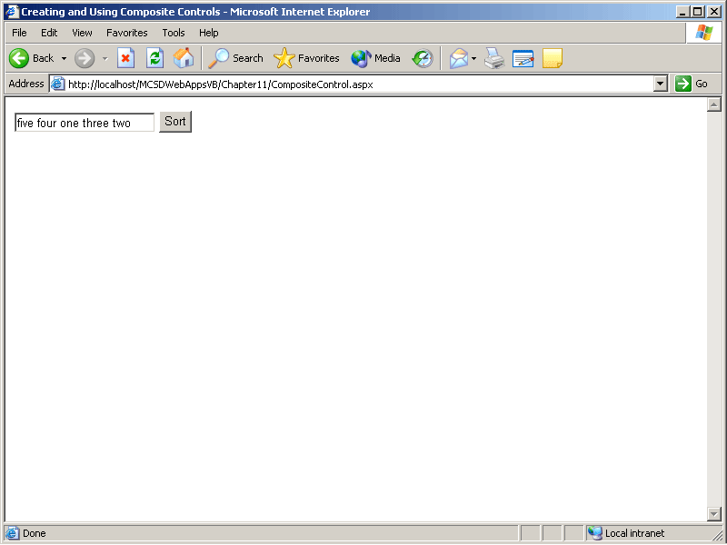
Figure 11-13. SuperText in action
Lesson 3: Creating Rendered Custom Controls
Rendered custom controls are created almost entirely from scratch, which means that you have complete control over how they appear and act. However, because they are not composed of child controls, the way composite controls are, you have to write code to perform the tasks that you could otherwise delegate to child controls.
Composite and rendered controls are closely related, and this lesson extends the skills you developed in Lesson 2. Some of the topics here apply equally to composite and rendered controls—you should consider this lesson to be advanced topics for Web custom control development. That said, there’s still a lot more that could be taught on the subject. For a comprehensive guide to developing Web custom controls, see Developing ASP.NET Server Controls and Components, by Nikhil Kothari and Vandana Datye (Microsoft Press, 2002).
After this lesson, you will be able to
- Create a custom control’s appearance using the Render method and the HtmlTextWriter utility methods
- Save and restore property values through the control’s ViewState
- Get text and controls contained between a custom control’s begin and end HTML tags
- Respond to user actions on a control by raising cached or postback events
- Get data that was entered on the control by the user
- Add custom controls to the Visual Studio .NET Toolbox
- Change the Toolbox icon and HTML TagPrefix used for the control by Visual Studio .NET
Estimated lesson time: 40 minutes
Creating and Using Rendered Controls
If you walked through the procedures described in Lesson 2, you’ve already created a rendered custom control. The code template that Visual Studio .NET generates when you create a Web Control Library project is, in fact, a rendered control, but it’s a simple control that doesn’t do much. You can create more interesting controls more quickly using composition, which is why we looked at creating composite controls before creating rendered controls.
Because rendered custom controls are very similar to composite custom controls, the techniques you learned in Lesson 2 apply throughout this lesson as well, with one exception: instead of creating the control’s visual interface from other controls, rendered controls create their visual interfaces exclusively from HTML elements. This means that you don’t have built-in properties, methods, or events you can use to get or display data; instead, you must create them yourself.
Creating rendered custom controls is similar to creating composite custom controls. To create rendered custom controls, follow these steps:
- Create a solution containing a custom control project.
- Add a Web application project to the solution, and set it as the startup project. You’ll use the Web application project to test the custom control during development.
- Add a project reference from the Web application to the custom control project, and then add an HTML @Register directive and control element to use the custom control on a Web form.
- Create the custom control’s visual interface by overriding the base class’s Render method.
- Write code to store property values, respond to user actions, and get data from the user as needed.
The following sections describe the last two steps in greater detail. The last two sections in this lesson show how to add completed custom controls to the Toolbox and how to set the icons and generated tags used by Visual Studio .NET for the controls. These last two sections apply equally to composite controls.
Creating the Rendered Control’s Appearance
You create a rendered custom control’s appearance by overriding the base class’s Render method and writing to the method’s output argument using the HtmlTextWriter utility methods. The HtmlTextWriter methods summarized in Table 11-3 let you add HTML to the output argument.
Table 11-3. HtmlTextWriter Utility Methods
Method | Description
AddAttribute | Adds an HTML attribute to the next HTML element to be rendered.
RenderBeginTag | Renders the begin tag of an HTML element for later writing by the WriteLine method.
RenderEndTag | Renders the end tag of an HTML element and writes the element and any rendered attributes that are pending. All rendered attributes are cleared after RenderEndTag.
Write | Immediately writes a string.
WriteAttribute | Immediately writes an HTML attribute.
WriteBeginTag | Immediately writes the begin tag of an HTML element.
WriteEndTag | Immediately writes the end tag of an HTML element.
WriteFullBeginTag | Immediately writes the begin tag along with the closing bracket (>) for the HTML element.
WriteLine | Immediately writes a line of content. This is equivalent to the Write method, but WriteLine adds a newline character as well.
As you can probably tell from Table 11-3, there are two approaches to writing HTML elements to the output argument. The most direct approach is to use the Write methods to add the HTML directly to HtmlTextWriter. For example, the following code creates a button that displays a message box when the user clicks it:
Visual Basic .NET
Imports System.ComponentModel
Imports System.Web.UI

Public Class AlertButton
Inherits System.Web.UI.WebControls.WebControl

Protected Overrides Sub Render(ByVal output As _
System.Web.UI.HtmlTextWriter)
' Write a title
output.Write("<h3>Rendered Control</h3>")
' Opens an Input HTML tag (inserts "<INPUT").
output.WriteBeginTag("INPUT")
' Write some attributes.
output.WriteAttribute("value", "Custom Button")
output.WriteAttribute("type", "button")
output.WriteAttribute("onclick", "javascript:alert('Howdy!')")
' Close the Input HTML tag (inserts ">").
output.WriteEndTag("INPUT")
End Sub

End Class
Visual C#
using System;
using System.Web.UI;
using System.Web.UI.WebControls;
using System.ComponentModel;

namespace csRenderedSnippet
{
public class AlertButton : System.Web.UI.WebControls.WebControl
{
protected override void Render(HtmlTextWriter output)
{
// Write a title
output.Write("<h3>Rendered Control</h3>");
// Opens an Input HTML tag (inserts "<INPUT").
output.WriteBeginTag("INPUT");
// Write some attributes.
output.WriteAttribute("value", "Custom Button");
output.WriteAttribute("type", "button");
output.WriteAttribute("onclick", "javascript:alert('Howdy!')");
// Close the Input HTML tag (inserts ">").
output.WriteEndTag("INPUT");
}
}
}
If you add this code to a custom control project, build the control, and then add the resulting custom control to a Web form, at run time the control will appear as shown in Figure 11-14.
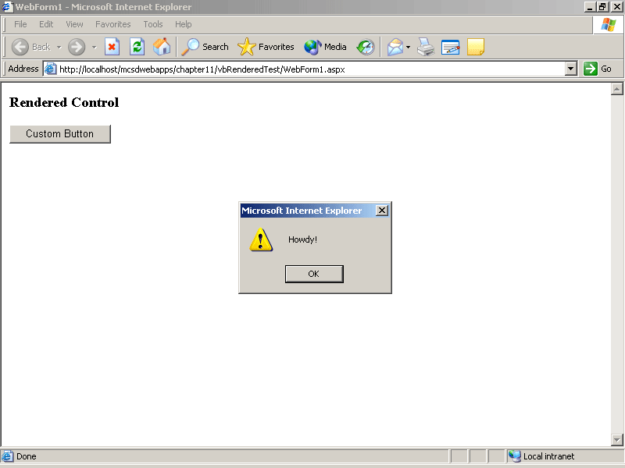
Figure 11-14. The AlertButton rendered custom control in action
As an alternative to writing directly to HtmlTextWriter, you can render tags and attributes and then write them as a unit using the RenderEndTag method. The following code shows the AlertButton custom control Render method written using this alternative approach:
Visual Basic .NET
Protected Overrides Sub Render(ByVal output As _
System.Web.UI.HtmlTextWriter)
' Write a title
output.Write("<h3>Rendered Control</h3>")
' Add some attributes.
output.AddAttribute("value", "Custom Button")
output.AddAttribute("type", "button")
output.AddAttribute("onclick", "javascript:alert('Howdy!')")
' Opens an Input HTML tag (inserts "<INPUT").
output.RenderBeginTag("INPUT")
' Close the Input HTML tag (inserts ">").
output.RenderEndTag()
End Sub
Visual C#
protected override void Render(HtmlTextWriter output)
{
// Write a title
output.Write("<h3>Rendered Control</h3>");
// Add some attributes.
output.AddAttribute("value", "Custom Button");
output.AddAttribute("type", "button");
output.AddAttribute("onclick", "javascript:alert('Howdy!')");
// Opens an Input HTML tag (inserts "<INPUT").
output.RenderBeginTag("INPUT");
// Close the Input HTML tag (inserts ">").
output.RenderEndTag();
}
The advantage of rendering the HTML elements in this way is that you can create the HTML attributes in any sequence.
Storing Property Settings
The composite custom control samples shown in Lesson 2 stored property settings using the properties from their contained controls. Because rendered controls don’t have contained controls, you must use the rendered control’s ViewState to store any property settings you want to retain between page displays.
The following code shows a Text property that retains its value between page displays:
Visual Basic .NET
Property Text() As String
Get
' If the property has been set
If Not IsNothing(ViewState("Text")) Then
' Return the settng.
Return ViewState("Text")
Else
' Otherwise return "".
Return ""
End If
End Get
Set(ByVal Value As String)
' Store the property setting.
ViewState("Text") = Value
End Set
End Property
Visual C#
public string Text
{
get
{
// If the property has been set
if (ViewState["Text"] != null)
// Return the settng.
return ViewState["Text"].ToString();
else
// Otherwise return "".
return null;
}

set
{
// Store the property setting.
ViewState["Text"] = value;
}
}
Setting ViewState serializes data and stores it in a hidden field on the Web form. When the page is posted back to the server, returning a value from ViewState retrieves and deserializes the data from the hidden field.
ViewState is optimized for String, ArrayList, and HashTable data types, but it can save any data that can be serialized or that provides a TypeConverter. For other types of data, you can create your own code to save and restore ViewState by overriding the SaveViewState and LoadViewState methods.
Getting Contained Text
HTML elements often enclose literal text that they modify in some way, as shown by the following HTML tags used to create boldface text:
<b>Bold me</b>
To get contained text from within a custom control, follow these steps:
- Add a ParseChildren attribute to the control’s class definition.
- Implement the INamingContainer interface in the custom control class.
- Retrieve the contained text using the Controls collection.
The following custom control class shows how to retrieve the text between a custom control’s begin and end tags to display the contained text in red:
Visual Basic .NET
' ParseChildren attribute enables contained controls.
<ParseChildren(False)> Public Class Red
Inherits WebControls.WebControl
' This interface makes it possible to get the Controls array.
Implements INamingContainer

Protected Overrides Sub Render(ByVal output As _
System.Web.UI.HtmlTextWriter)
' Contained text is returned as a Literal control.
Dim litText As LiteralControl
' Get the contained text from the Controls collection.
litText = Controls(0)
' Make it red using the <font> element.
output.Write("<font color='red'>" & litText.Text & "</font>")
End Sub

End Class
Visual C#
[ParseChildren(false)]
public class Red : System.Web.UI.WebControls.WebControl, INamingContainer
{
// INamingContainer interface makes it possible to get the Controls array.

protected override void Render(HtmlTextWriter output)
{
// Contained text is returned as a Literal control.
LiteralControl litText ;
// Get the contained text from the Controls collection.
litText = (LiteralControl)Controls[0];
// Make it red using the <font> element.
output.Write("<font color='red'>" + litText.Text + "</font>");
}
}
On a Web form, you would use the preceding custom control through the following HTML:
<custom:red id="Red1" runat="server">Some red text</custom:red>
You can use the Controls collection to get any items that exist between the custom control’s begin and end tags, including other controls. For example, the following custom control class groups contained controls in a panel, centers the controls on the page, and displays them on a red background:
Visual Basic .NET
' ParseChildren attribute enables contained controls.
<ParseChildren(False)> Public Class Center
Inherits WebControls.WebControl
' This interface makes it possible to get the Controls array.
Implements INamingContainer

Protected Overrides Sub Render(ByVal output As _
System.Web.UI.HtmlTextWriter)
' Add some attributes for the panel.
output.AddAttribute("align", "center")
output.AddStyleAttribute("BACKGROUND-COLOR", "red")
' Start a panel
output.RenderBeginTag("div")
' Declare a variable to get contained controls.
Dim ctrItem As Control
' For each contained control.
For Each ctrItem In Controls
' Render the control
ctrItem.RenderControl(output)
Next
output.RenderEndTag()
End Sub

End Class
Visual C#
[ParseChildren(false)]
public class Center : System.Web.UI.WebControls.WebControl,
INamingContainer
{
// INamingContainer interface makes it possible to get the Controls array.

protected override void Render(HtmlTextWriter output)
{
// Add some attributes for the panel.
output.AddAttribute("align", "center");
output.AddStyleAttribute("BACKGROUND-COLOR", "red");
// Start a panel
output.RenderBeginTag("div");
// For each contained control.
foreach (Control ctrItem in Controls)
{
// Render the control
ctrItem.RenderControl(output);
}
output.RenderEndTag();
}
}
Responding to User Actions
Composite custom controls can use their contained controls’ events to respond to user actions, as shown in Lesson 2. Rendered controls, however, need to take special steps to respond to user actions. How you deal with user actions depends on the type of event:
- Cached events can be raised from the custom control’s code.
- Postback events must be raised from the client side using a script rendered by the custom control.
The following sections show how to raise each of these types of events.
Raising Cached Events
Cached events are handled by the Web form’s server-side code when the Web form is posted back to the server and after the Load and postback events have been handled. Raising a cached event involves two steps:
- Declare an event to raise.
- Raise the event from somewhere within the custom control’s code.
For example, the following custom control class defines an OnChange event that is raised whenever the Text property changes:
Visual Basic .NET
<DefaultEvent("OnChange")>Public Class RenderText
Inherits WebControls.WebControl

Event Change(ByVal sender As Object, ByVal e As EventArgs)

Property Text() As String
Get
' If the property has been set
If Not IsNothing(ViewState("Text")) Then
' Return the settng.
Return ViewState("Text")
Else
' Otherwise return "".
Return ""
End If
End Get
Set(ByVal Value As String)
' Store the property setting.
ViewState("Text") = Value
OnChange(EventArgs.Empty)
End Set
End Property

' Event method.
Protected Overridable Sub OnChange(ByVal e As EventArgs)
' Raise event.
RaiseEvent Change(Me, EventArgs.Empty)
End Sub

Protected Overrides Sub Render(ByVal output As _
System.Web.UI.HtmlTextWriter)
' Set the Input control's attributes.
output.AddAttribute("value", Me.Text)
' Create an Input control element using above.
output.RenderBeginTag("Input")
' Close the Input control element (inserts />).
output.RenderEndTag()
End Sub

End Class
Visual C#
[DefaultEvent("Change")]
public class RenderText : System.Web.UI.WebControls.WebControl
{
// Declare event.
public event EventHandler Change;

public string Text
{
get
{
// If the property has been set
if (ViewState["Text"] != null)
// Return the settng.
return ViewState["Text"].ToString();
else
// Otherwise return "".
return null;
}
set
{
// Store the property setting.
ViewState["Text"] = value;
// Call event method.
OnChange(EventArgs.Empty);
}
}

protected virtual void OnChange(EventArgs e)
{
if (Change != null)
// Raise event.
Change(this, e);
}

protected override void Render(HtmlTextWriter output)
{
// Set the Input control's attributes.
output.AddAttribute("value", this.Text);
// Create an Input control element using above.
output.RenderBeginTag("Input");
// Close the Input control element (inserts />).
output.RenderEndTag();
}
}
Notice that the class definition above sets Change as the default event for the control. That means that Visual Studio .NET will generate the event procedure if you double-click the custom control in the Web Forms Designer.
Use the following code to handle the Change event from the Web form:
Visual Basic .NET
Private Sub txtTest_OnChange(ByVal sender As System.Object, _
ByVal e As System.EventArgs) Handles txtTest.OnChange
Response.Write("Text changed!")
End Sub
Visual C#
private void txtTest_Change(object sender, System.EventArgs e)
{
Response.Write("Text changed!");
}
Raising Postback Events
Postback events cause the Web form to be posted back to the server for immediate processing. They are handled immediately after the Web form’s Load event. To raise a postback event from a custom control, follow these steps:
- Implement the IPostBackEventHandler interface in the custom control.
- Declare an event to raise.
- Render an HTML element that can respond to client-side events, such as OnClick.
- Add an attribute to the HTML element containing a script to post the page back to the server.
- Raise the event from the RaisePostBackEvent method, which is part of the IPostBackEventHandler interface.
The following code shows how to use these steps to raise the Click postback event from a custom control:
Visual Basic .NET
' Raises PostBack event.
<DefaultEvent("Click")> Public Class AlertButton
Inherits System.Web.UI.WebControls.WebControl
' (1) Interface that allows PostBack event processing.
Implements IPostBackEventHandler

' (2) Declare postback event
Event Click(ByVal sender As Object, ByVal e As EventArgs)

' (3) Render an HTML element that can detect user events.
Protected Overrides Sub Render(ByVal output As _
System.Web.UI.HtmlTextWriter)
' Add some attributes.
output.AddAttribute("value", "Postback Button")
output.AddAttribute("type", "button")
' (4) Add attribute to raise Postback event on client.
output.AddAttribute("onclick", "javascript:alert('Howdy!');" & _
Page.GetPostBackEventReference(Me))
' Opens an Input HTML tag (inserts "<INPUT").
output.RenderBeginTag("INPUT")
' Close the Input HTML tag (inserts ">" and writes attributes).
output.RenderEndTag()
End Sub

' Part of the IPostBackEventHandler interface.
' you must create this method.
Public Sub RaisePostBackEvent(ByVal eventArgument As String) _
Implements System.Web.UI.IPostBackEventHandler.RaisePostBackEvent
' (5) Raise the event.
OnClick(EventArgs.Empty)
End Sub

Protected Overridable Sub OnClick(ByVal e As EventArgs)
' Raise the event.
RaiseEvent Click(Me, EventArgs.Empty)
End Sub

End Class
Visual C#
// (1) IPostBackEventHandler interface allows PostBack event processing.
[DefaultEvent("Click")] public class AlertButtonThree :
System.Web.UI.WebControls.WebControl, IPostBackEventHandler
{
// (2) Declare postback event
public event EventHandler Click;

// (3) Render an HTML element that can detect user events.
protected override void Render(HtmlTextWriter output)
{
// Write a title
output.Write("<h3>Rendered Control</h3>");
// Add some attributes.
output.AddAttribute("value", "Custom Button");
output.AddAttribute("type", "button");
// (4) Add attribute to raise Postback event on client.
output.AddAttribute("onclick", "javascript:alert('Howdy!');" +
Page.GetPostBackEventReference(this));
// Opens an Input HTML tag (inserts "<INPUT").
output.RenderBeginTag("INPUT");
// Close the Input HTML tag (inserts ">").
output.RenderEndTag();
}

// Part of the IPostBackEventHandler interface.
// you must create this method.
public void RaisePostBackEvent(string eventArgument)
{
// (5) Call the event method to raise event.
OnClick(EventArgs.Empty);
}

protected virtual void OnClick(EventArgs e)
{
// Raise the event.
if (Click != null)
Click(this, e);
}

}
When the user clicks the preceding custom control at run time, the button’s OnClick event runs the following script:
alert('Howdy!'); //Displays a message box.
__doPostBack('winTest',''); //Generated by Page.GetPostBackEventReference(Me);
The __doPostBack method posts the page back to the server, where it is intercepted by the IPostBackEventHandler interface’s RaisePostBackEvent method, which in turn raises the Click event from within the control.
Use the following code to handle the Click event from the Web form:
Visual Basic .NET
Private Sub altTest_Click(ByVal sender As System.Object, _
ByVal e As System.EventArgs) Handles altTest.Click
Response.Write("Button clicked!")
End Sub
Visual C#
private void altTest(object sender, System.EventArgs e)
{
Response.Write("Button clicked!");
}
Getting Data from the User
Rendered controls don’t automatically retain the data entered by the user. You can see this if you create a TextBox custom control by rendering an HTML Input element: you can type in the Input element, but as soon as the page is posted back to the server, whatever you typed is gone.
To get data from the user, follow these steps:
- Implement the IPostBackDataHandler interface.
- Add a name attribute to uniquely identify the HTML element to get data from.
- Override the LoadPostBackData method from the IPostBackDataHandler interface. Use this method to get the data from the user.
- Override the RaisePostDataChangedEvent method from the IPostBackDataHandler interface. You don’t have to write code for this method, but you must override it because it is part of the interface.
- Raise an event to indicate that the data has changed. This step is optional—if you don’t want to provide a change event for the control, you don’t have to.
The following custom control shows how to use these steps to retain data entered by a user in a custom TextBox control rendered from an HTML Input element:
Visual Basic .NET
<DefaultEvent("Change")> Public Class RenderText
Inherits WebControls.WebControl
' (1) Interface that allows you to get PostBack data.
Implements IPostBackDataHandler

Event Change(ByVal sender As Object, ByVal e As EventArgs)

Property Text() As String
Get
' If the property has been set
If Not IsNothing(ViewState("Text")) Then
' Return the settng.
Return ViewState("Text")
Else
' Otherwise return "".
Return ""
End If
End Get
Set(ByVal Value As String)
' Store the property setting.
ViewState("Text") = Value
' Call event method.
OnChange(EventArgs.Empty)
End Set
End Property

Protected Overrides Sub Render(ByVal output As _
System.Web.UI.HtmlTextWriter)
' Set the Input control's attributes.
output.AddAttribute("value", Me.Text)
' (2) You must define this attribute to enable PostBack data.
output.AddAttribute("name", Me.UniqueID)
' Create an Input control element using above.
output.RenderBeginTag("Input")
' Close the Input control element.
output.RenderEndTag()
' Write the element to the HtmlTextWriter.
output.WriteLine()
End Sub

' (3) Get data from the user.
' You must create this method.
Public Function LoadPostData(ByVal postDataKey As String, _
ByVal postCollection As _
System.Collections.Specialized.NameValueCollection) As Boolean _
Implements System.Web.UI.IPostBackDataHandler.LoadPostData
' If the user changes Input value, update the text property.
If Me.Text <> postCollection(postDataKey) Then
Me.Text = postCollection(postDataKey)
' Returning True invokes RaisePostDataChangedEvent below.
Return True
Else
' Returning False does not invoke RaisePostDataChangedEvent.
Return False
End If
End Function

' (4) Override RaisePostDataChangedEvent method.
' You must create this method.
Public Sub RaisePostDataChangedEvent() Implements _
System.Web.UI.IPostBackDataHandler.RaisePostDataChangedEvent
' (5) Call the event method. This is optional.
OnChange(EventArgs.Empty)
End Sub

' Event method.
Protected Overridable Sub OnChange(ByVal e As EventArgs)
' Raise event
RaiseEvent Change(Me, EventArgs.Empty)
End Sub
End Class
Visual C#
// (1) IPostBackDataHandler interface allows you to get PostBack data.
[DefaultProperty("Text"), DefaultEvent("Change")] public class RenderText :
System.Web.UI.WebControls.WebControl, IPostBackDataHandler
{
// Declare event.
public event EventHandler Change;

[DefaultValue("")]
public string Text
{
get
{
// If the property has been set
if (ViewState["Text"] != null)
// Return the settng.
return ViewState["Text"].ToString();
else
// Otherwise return "".
return null;
}

set
{
// Store the property setting.
ViewState["Text"] = value;
// Call event method.
OnChange(EventArgs.Empty);
}
}

protected override void Render(HtmlTextWriter output)
{
// Set the Input control's attributes.
output.AddAttribute("value", this.Text);
// (2) You must define this attribute to enable PostBack data.
output.AddAttribute("name", this.UniqueID);
// Create an Input control element using above.
output.RenderBeginTag("Input");
// Close the Input control element (inserts />).
output.RenderEndTag();
}

// (3) Get data from the user.
// You must create this method.
public bool LoadPostData(string postDataKey,
System.Collections.Specialized.NameValueCollection postCollection)
{
// If the user changes Input value, update the text property.
if (this.Text != postCollection[postDataKey])
{
this.Text = postCollection[postDataKey];
// Returning true invokes RaisePostDataChangedEvent.
return true;
}
else
// Returning False does not invoke RaisePostDataChangedEvent.
return false;
}

// (4) Override RaisePostDataChangedEvent method.
// You must create this method.
public void RaisePostDataChangedEvent()
{
// (5) Call the event method. This is optional.
OnChange(EventArgs.Empty);
}

protected virtual void OnChange(EventArgs e)
{
if (Change != null)
// Raise event.
Change(this, e);
}
}
Adding Custom Controls to the Toolbox
After you’ve created and debugged a set of custom controls, you can add them to the Visual Studio .NET Toolbox by following these steps:
- Choose Customize Toolbox from the Tools menu. Visual Studio .NET displays the Customize Toolbox dialog box, as shown in Figure 11-15.
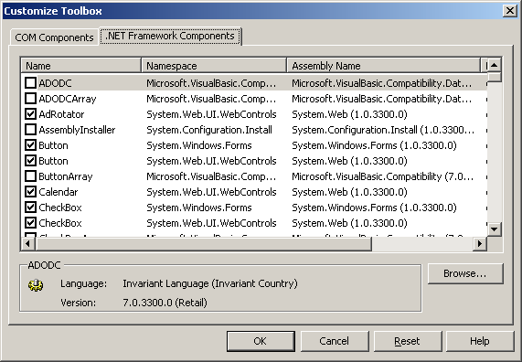
Figure 11-15. Adding items to the Toolbox
- Click the .NET Framework Components tab, and then click Browse. Visual Studio .NET displays the Open dialog box.
- Use the Open dialog box to locate and select the assembly (.dll) containing the custom controls to add to the Toolbox, and then click Open. Visual Studio .NET opens the assembly and adds the contained controls to the list of controls in the Customize Toolbox dialog box.
- Click OK to close the Customize Toolbox dialog box.
After you’ve added custom controls to the Toolbox, they appear under the General category when Visual Studio .NET is in Design mode, as shown in Figure 11-16.
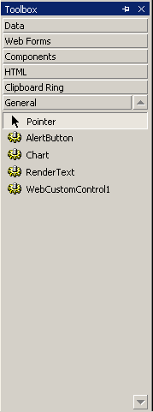
Figure 11-16. Custom controls in the Toolbox
To add a custom control to a Web form, simply double-click the control or drag the control from the Toolbox to the Web form. When you add a custom control from the Toolbox, Visual Studio .NET automatically adds the @Register directive for the control to the Web form and inserts the HTML for the custom control, as shown in boldface in the following HTML:
<%@ Page Language="vb" AutoEventWireup="false" Codebehind="CustomControl.aspx.vb" Inherits=" MCSDWebAppsVB.CustomControl"%>
<%@ Register TagPrefix="Custom" Namespace="RenderedControls"
Assembly="RenderedControls" %><HTML>
<body>
<form id="Form1" method="post" runat="server">
<Custom:Chart id="Chart1" runat="server"></cc1:Chart>
</form>
</body>
</HTML>
The icons that appear for the custom control in the Toolbox and the TagPrefix used in the HTML for the control can be changed using attributes in the custom control’s assembly, as described in the following section.
Setting the Toolbox Icon and TagPrefix for Custom Controls
You can customize your controls to display unique icons in the Toolbox and use their own TagPrefix attributes in HTML. If you’ve already added the custom controls to your Toolbox, you must unload them and then add them back to the Toolbox before any of these changes take effect.
To add a Toolbox icon to a custom control, follow these steps:
- Create a 16-by-16 bitmap file containing the icon to display in the Toolbox.
- Name the bitmap file using the same base name as the class name for the custom control it represents. For example, Red.bmp is the icon for the custom control with the class name Red.
- Set the bitmap file’s Build Action property to Embedded Resource in Solution Explorer.
- Rebuild the control.
To change the TagPrefix used by a custom control in HTML, follow these steps:
- Add the following lines to the custom control project’s AssemblyInfo file:
Visual Basic .NET
Imports System.Web.UI

<Assembly: TagPrefix("project.namespace", "prefix")>
Visual C#
using System.Web.UI

[assembly: TagPrefix("namespace", "prefix")]
- Rebuild the project.
In the preceding procedure, project.namespace is the project name and namespace for the custom control, and prefix is the prefix to use for the custom controls from that namespace.
Summary
- Create user controls by drawing server and HTML controls on a user control page (.ascx).
- Add a user control to a Web form by dragging the control from Solution Explorer, instead of from the Toolbox.
- User controls must be part of the project in which they are used and are initialized after their containing Web form’s Load event.
- Create composite custom controls by defining a class derived from the WebControl base class.
- Composite controls are made up of server and HTML controls added through the CreateChildControls method.
- To add features to an existing server control, superclass that control by deriving a new custom control from the existing control’s class.
- Rendered custom controls provide more control over the appearance and behavior of the control, but they require more programming to handle the tasks that composite custom controls usually handle through their child controls.
- Use the Render method and the HtmlTextWriter utility methods to create the appearance of a rendered custom control.
- Use the IPostBackEventHandler interface to enable a rendered control to trigger postback events.
- Use the IPostBackDataHandler interface to enable a rendered control to get data that the user enters in a control at run time.
Lab: Creating Custom Controls
In this lab, you’ll create a test Web application project to contain the three different controls you create in each of the exercises. When complete, the controls will appear on the Web form, as shown in Figure 11-17.
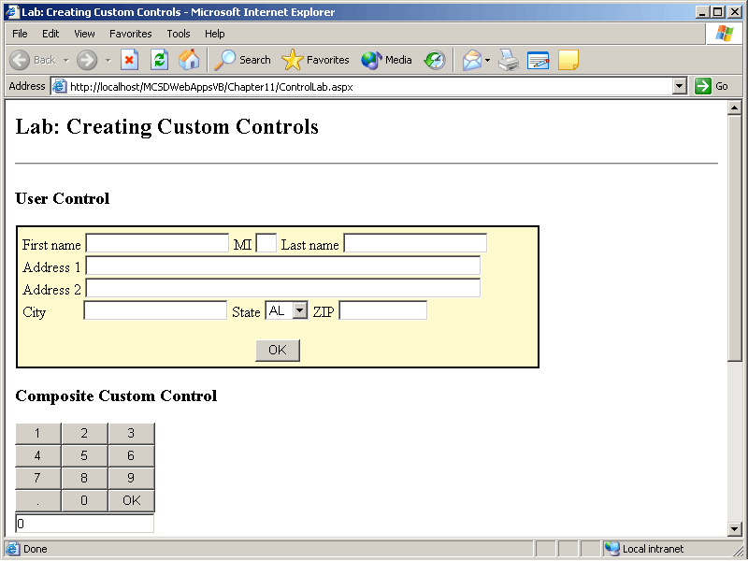
Figure 11-17. The completed test application with user and custom controls
Estimated lesson time: 60 minutes
Exercise 1: Create an AddressBox User Control

In this exercise, you’ll create a Web application containing a user control that gathers name and address information. Use the skills you developed in Lesson 1 to create and test a user control by completing the following major tasks:
- Create a Web application project.
- Add a user control page (.ascx) that contains text and controls for collecting name, address, city, state, and ZIP code information.
- Use validation controls within the user control to ensure that required fields are completed.
- Use a Grid Layout Panel HTML control to format and position the text and controls within the user control.
- Provide a Click event that is fired from the user control after the data entries are validated.
- Provide public read-only properties to return address information from the user control.
- Provide a public read/write Style property to support absolute positioning in grid layout.
- Test the user control by adding it to a Web form and accessing its event and properties from code.
When you have finished (or if you get stuck), compare your results to the AddressBox user control included on the companion CD.
Exercise 2: Create the DigitPad Composite Custom Control
In this exercise, you’ll create a Web Control Library containing a custom control that allows the user to enter numbers by clicking buttons. Use the skills you developed in Lesson 2 to create and test the custom control by completing the following major tasks:
- Add a Web Control Library project to the solution you created in the previous exercise.
- Add a reference from the user control project to the Web Control Library project so that you can test the custom control from Web forms within that project.
- Create a composite custom control that uses InputButton HTML controls to accept numeric input.
- Provide a postback event that is fired from the custom control once the numeric data is complete.
- Provide a public read-only property to return the number entered in the control.
- Test the user control by adding it to a Web form and accessing its events and properties from code.
When you have finished, compare your results to the DigitPad custom control included on the companion CD.
Exercise 3: Create the BarChart Rendered Custom Control
In this exercise, you’ll add a rendered custom control to the Web Control Library you created in Exercise 2. The custom control will create a simple bar chart from numbers entered between the HTML begin and end tags of the custom control. Use the skills you developed in Lesson 3 to create and test the custom control by completing the following major tasks:
- Add a new Web custom control class to the Web Control Library project you created in the previous exercise.
- Create a Values property that gets an array of data from text entered between the begin and end tags of the custom control.
- Create a ChartTitle property that sets or returns a heading displayed at the top of the chart.
- Override the control’s Render method to create a bar chart from the data in the Values property. To simplify the charting, use Horizontal Rule HTML controls (<HR>) to create the chart.
- Test the user control by adding it to a Web form and accessing its events and properties from code.
Compare your results to the BarChart custom control included on the companion CD.
Review
The following questions are intended to reinforce key information presented in this chapter. If you are unable to answer a question, review the appropriate lesson and then try the question again. Answers to the questions can be found in the appendix.
- Briefly describe the best uses for each of the three types of Web controls by completing the following sentences:
  - Create a Web user control when you want to...
  - Create a composite custom control when you want to...
  - Create a rendered custom control when you want to...
- How is deriving important to creating custom Web controls?
- What is the most important method to override when you’re creating a composite custom control?
- What is the most important method to override when you’re creating a rendered control?
- How is raising a postback event in a composite control different from raising a postback event in a rendered control?

